Mascot, Colors, and School Song

Mascot
Fightin’ Irish
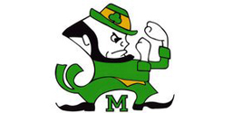

Colors
The official school colors are dark green and white.

School Song
Go, McNamara Irish, tried and true,
We will sing your praises, McNamara—
We’re for you, Ra! Ra! Ra!
Lead on to vict’ry, noble green and white.
Colors so bold, we’ll always honor McNamara.
FIGHT, FIGHT, FIGHT
(Repeat verse)
Tee Ho, Tee HoHo, Irish, Irish, Go, Go, Go!
Tee Ha, Tee HaHa, Irish, Irish, Ra, Ra, Ra!

