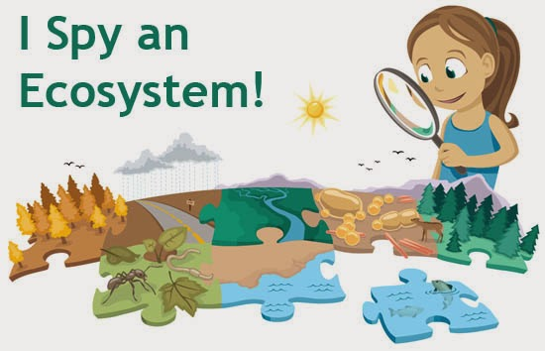
5th Grade Biome Project

Name __________________________________
Biome Project Grading Rubric
Shoebox Contents | Points | Comments
- 3-5 animals | /10
- Appropriate vegetation | /10
- Biotic Factors (at least 5) | /10
- Abiotic Factors (at least 2 in the habitat) soil, sand, rocks, water, etc. | /10
- Climate represented in habitat | /10
- 3-D format | /10
- Neatness/Spelling/Grammar | /15
- Biome Explanation: Should list any biotic/abiotic factors in the habitat. Include average temperature and precipitation of your biome. | /20
Biome labeled/your name on project clearly visible | /5
Total Points | /100 | /100

5th graders, as part of our ecosystems unit, it’s time to pick your favorite biome and create a habitat to show what you know! Find a shoebox, decide what your habitat will be, and get creative. You will need to focus on what is listed in the rubric above and then start researching what belongs in your biome. Remember, you must have a 3D environment, but the point is to use a variety of materials (paper, outside materials, craft supplies, etc.) to get a look inside of your shoebox into a tiny version of the real thing! When your biome is complete, you will also need to write a paragraph explaining what the biotic/abiotic factors of your biome are, including the climate and any other interesting facts you learned about your biome. You can put this on the back of your shoebox, and be sure to use your very best writing. You are almost in 6th grade now, right? Your science book has a lot of information about different biomes (pp. 66-82). Your biome project is due on May 19, so it’s time to get started! This will be done outside of school, but you can always use your laptop to research or find pictures to print at school. If you have any questions, you know where to find me . Oh, and be sure to show this note to your parents TODAY!! I can’t wait to see your amazing creations!

Mrs. Thompson

