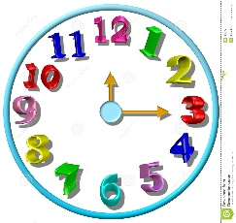
Aleks rubric – 1 hour week
Time | Grade
60 + | A
50-59 | B
40-49 | C
30-39 | D
29 | F

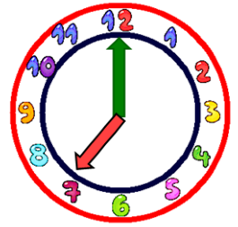
Aleks rubric – 1.5 hour week
Time | Grade
90 + | A
75-89 | B
60-74 | C
45-59 | D
44 | F

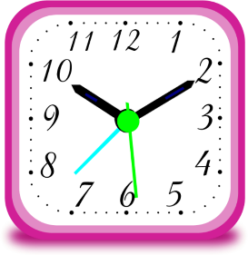
Aleks rubric – 2 hour week
Time | Grade
120 + | A
100-119 | B
80-99 | C
60-79 | D
59 | F

